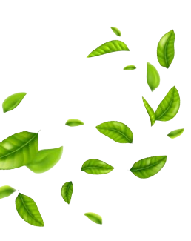





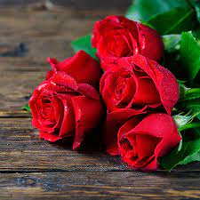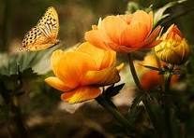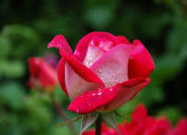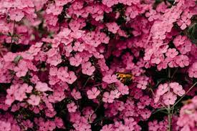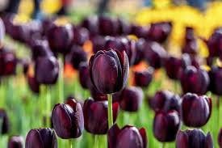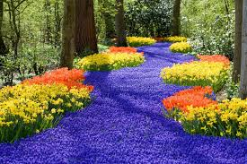

* Prepared by : **SHARIQ Ahmed Khan**

flowers are an essential part of our lives. They are responsible for bringing happiness in our lives and making our surrounding environment a prettier place to live in.

**FLORAL’S**

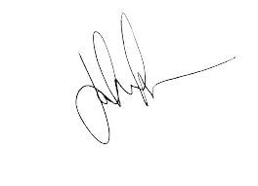

* Acknowledgement
* Introduction
* What’s This E-Project
* Objectives of the Project
* Problem Statement
* Requirement Specification
* Source Code

**Table OF CONTENT**

This is to certify that **SHARIQ Ahmed Khan** have successfully completed their ACCP Semester I E-Project.

**SHARIQ Ahmed Khan**

**Signature**

THE CERTIFICATE IS PRESENTED TO

**CERTIFICATE**

OF COMPLETION

**Submitted to: Aptech Computer Education**

**On**

Tuesday,February 13,2024





First of all, we would like to thank Almighty Allah for giving us the strength and ability to complete this project. And then, we would like to express our special gratitude to our teacher, Miss KIRAN SHAKEEL, who guided us on FLORAL’S, which helped us in acquiring a lot of new knowledge. We are truly thankful to her. We are highly appreciative of Miss KIRAN SHAKEEL for her guidance, constant supervision, and provision of necessary information regarding the project. Additionally, we extend our gratitude to our parents and friends who aided us significantly in finalizing this project within the limited timeframe. We also express sincere thanks to the E-Project team from Aptech Head Office for their valuable guidance and support throughout the project completion process. We sincerely hope that this project will provide all the necessary information required by the user to fulfill their inspiration. Nevertheless, suggestions and feedback for improvements will be warmly welcomed and acknowledged.

# Acknowledgment

A flower is the reproductive part of flowering plants. Flowers are also called the bloom or blossom of a plant. Flowers have petals. Inside the part of the flower that has petals are the parts which produce pollen and seeds Flower is the main reproductive part of the plant. It is made up of four whorls and out of them two outer whorls are the calyx and corolla. The inner two whorls are androecium or the male part of the flower and gynoecium or the female part of the flower. What is a Flowering Plant? Flowering plants are plants that bear flowers and fruits and form the clade Angiospermae, commonly called angiosperms. The term "angiosperm" is derived from the Greek words Ange ion and sperm a, and refers to those plants that produce their seeds enclosed within a fruit.

# Introduction



# What’s This E-Project

E-Project is a step-by-step learning environment that closely simulates the classroom

and Lab based learning environment into actual implementation. It is a project

implementation at your fingertips!! An electronic, live juncture on the machine that

allows you to

* Practice step by step i.e. laddered approach.
* Build a larger more robust application.
* Usage of certain utilities in applications designed by user.
* Single program to unified code leading to a complete application.
* Learn implementation of concepts in a phased manner.
* Enhance skills and add value.
* Work on real life projects.
* Give a real life scenario and help to create applications more complicated and

useful.

* Mentoring through email support.

The students at the centre are expected to complete this E-Project and send complete

project along with the documentation to E-Projects Team

Looking forward to a positive response from your end!!

The Objective of this program is to give a sample project to work on real life

projects. These applications help you build a larger more robust application.

The objective is not to teach you JavaScript/Dream-weaver but to provide you with a

real life scenario and help you create basic applications using the tools.

You can revise the chapters before you start with the project.

This project is meant for students who have completed the module of

Dream-weaver. These programs should be done in the Lab sessions with assistance

of the faculty if required.It is very essential that a student has a clear understanding of the subject. Students should go through the project and solve the assignments as per requirements given.Kindly get back to E-Projects Team in case of any doubts regarding the application or its objectives.

# Objectives of the Project



Flowers are exposed to chemicals at many stages of their life cycle. The most problematic chemicals are pesticides, which are used to protect crops against pests. Pesticides vary a lot in their chemical composition, and some are more toxic than others for animals and humans.

# Problem Statement



Our client, java Florist wants the following actions to be implemented.

1. The application will have a web page which have links or option

home, My account, about flowers, view cart, ,florist registration

etc.

2. the home page will also have link for different occasions and

when the user clicks on any occasion the bouquets available

with that occasion would be displayed with there price.

3. If the user wants to book any bouquets he has to register

himself. At a time the user can book more than one bouquets. At

the time of booking the bouquets gets attached to cart and the

total price will be calculated.

4. The price would be paid through credit card.

5. After paying the money it should also collect the information to

whom the bouquet have to be delivered, their name, address,

phone no and the message.

6. For messages there would be dropdown list having all the

occasion in the list. According to the selected occasion

predefined messages will be displayed and the user can choose

one of them. Also he can write his own message in the text area

provided.

7. The bouquet will be delivered with in the five hour of the

booking. The working hour of the florist is morning 9 a.m to

evening 9 p.m. If the booking order is within the five hours of

working hour the bouquet will be delivered on the same day

otherwise it will be delivered on the next day.

8. Admin login should able to update and delete the bouquets

available, there price etc.

# Requirement Specification





c

c



c

c



c



c

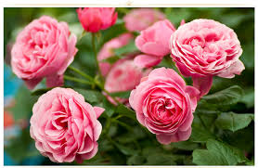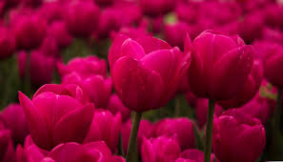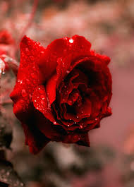

“ Thank you for being here on our journey ”

**Thank You**

